Section 4:

**Making Real Projects with Docker:**

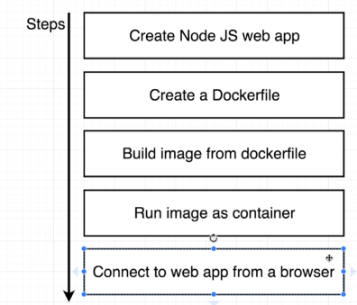

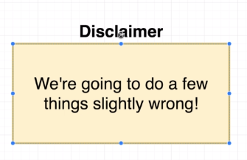

Here's what you'll need to do:

1) Create a new file called package.json and copy paste the following into it:

1. {
2. "dependencies": {
3. "express": "*"
4. },
5. "scripts": {
6. "start": "node index.js"
7. }
8. }

2) Create a new file called index.js and copy paste the following into it:

1. const express = require('express');
3. const app = express();
5. app.get('/', (req, res) => {
6. res.send('How are you doing');
7. });
9. app.listen(8080, () => {
10. console.log('Listening on port 8080');
11. });

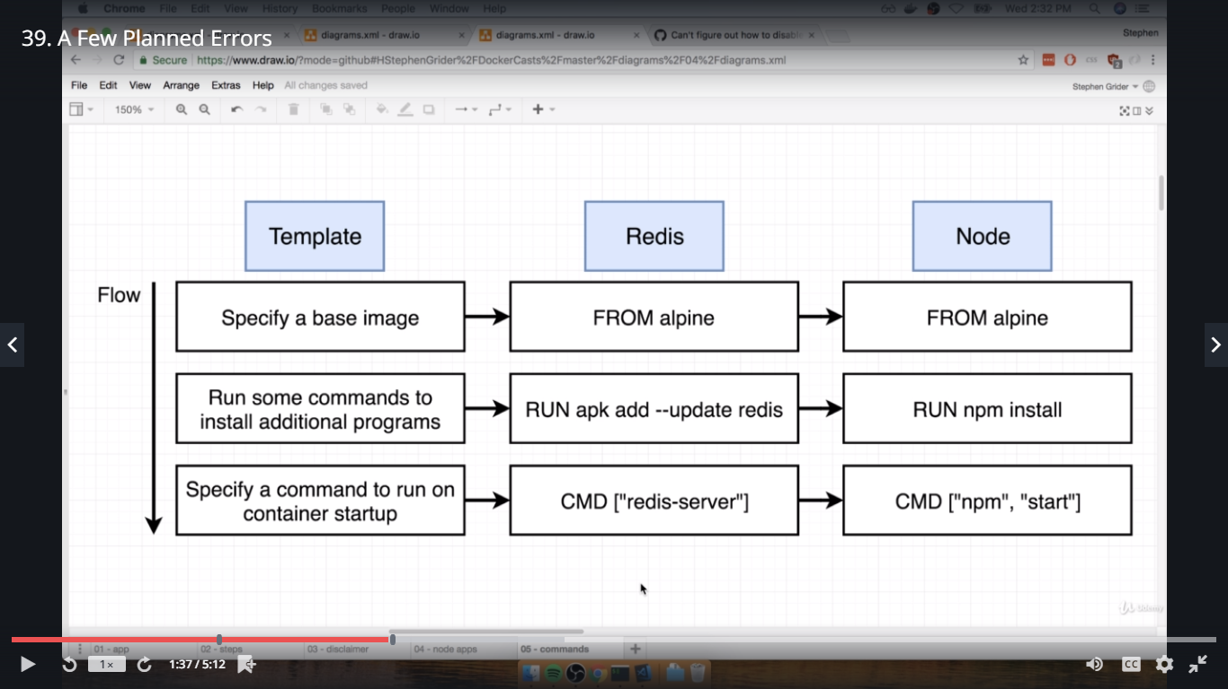

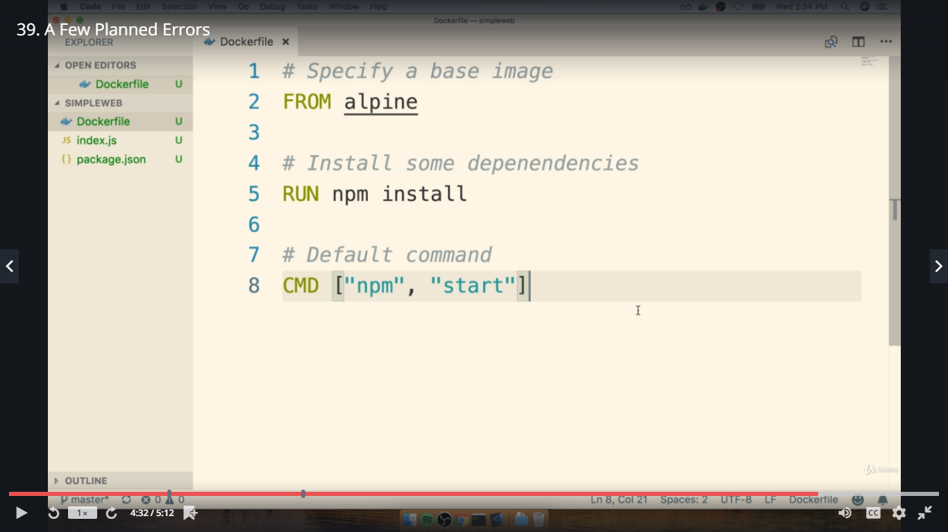

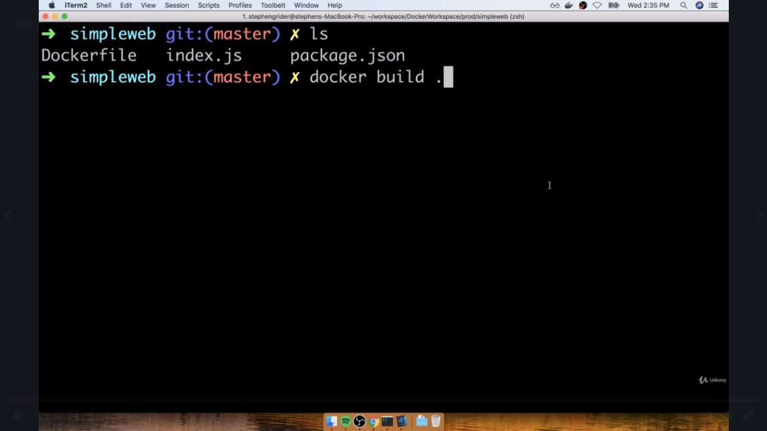

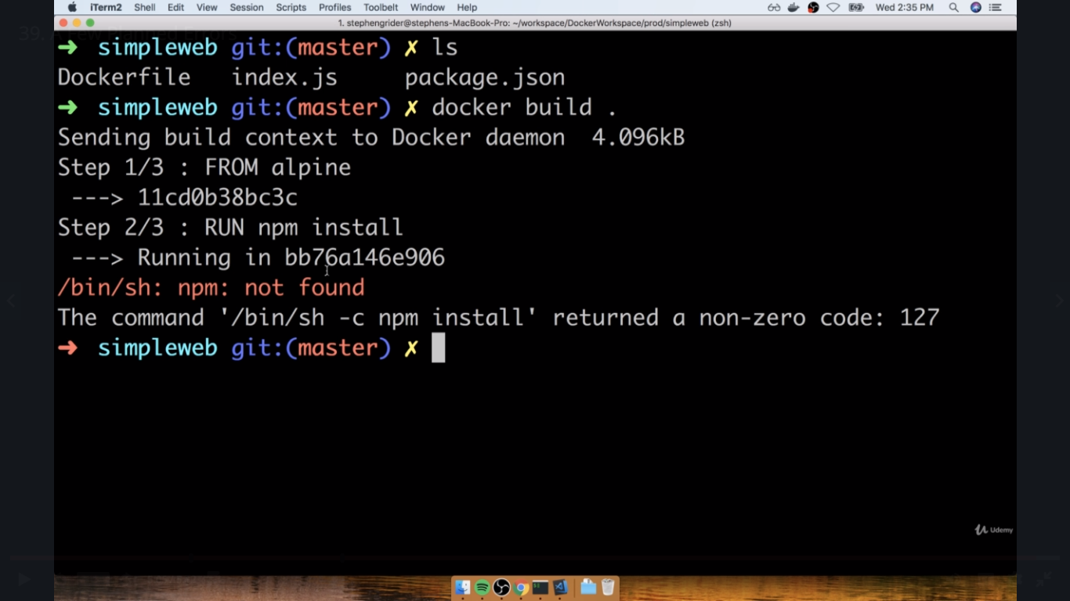

**NPM is not available inside alpine image.. so we will download image that have alpine included NPM**

[**https://hub.docker.com**](https://hub.docker.com) **-> explore -> alpine**

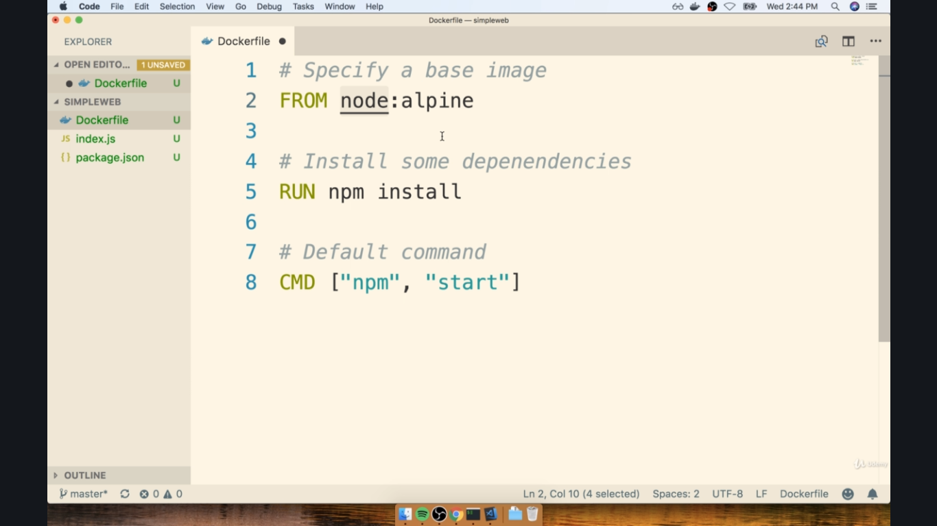

**Again run the docker file**

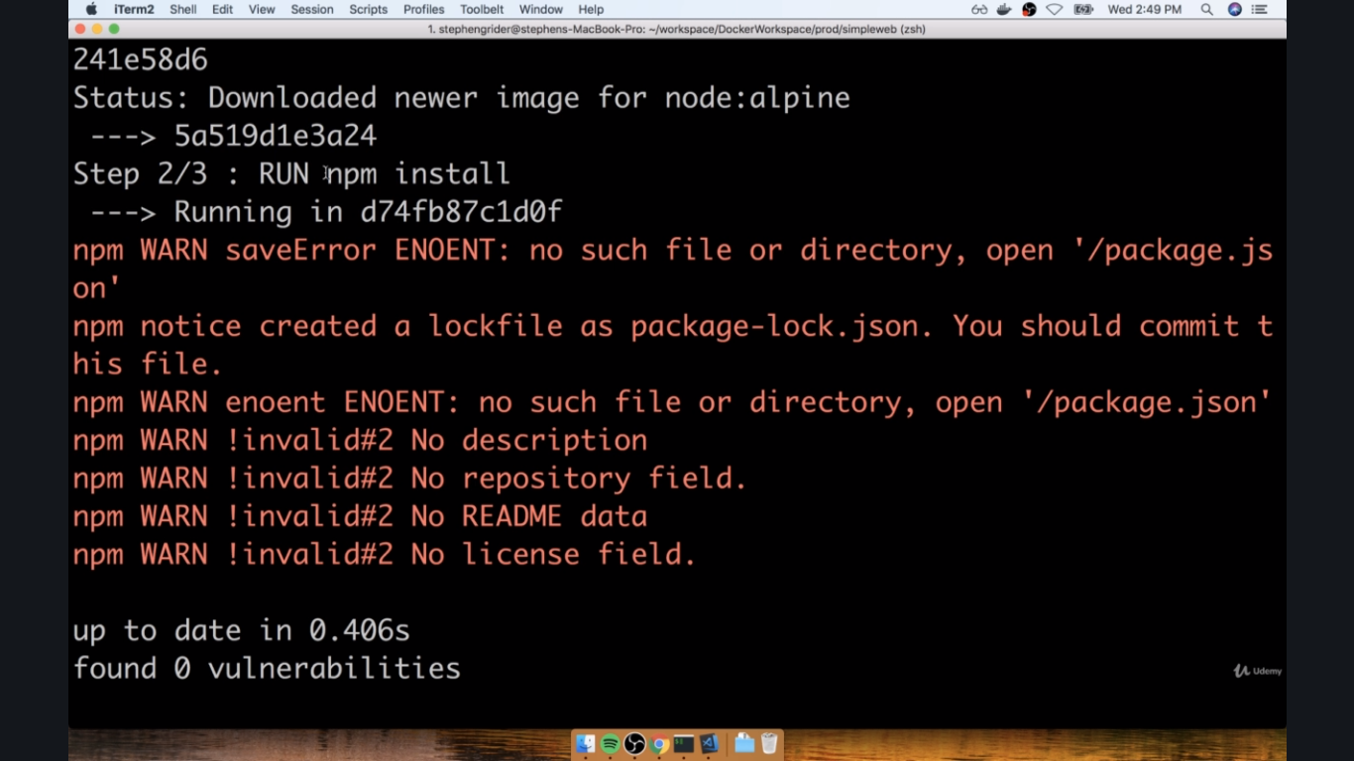

**Get error again.. because npm is not able to find the file that we created.. as we have to copy the files insidethe docker**

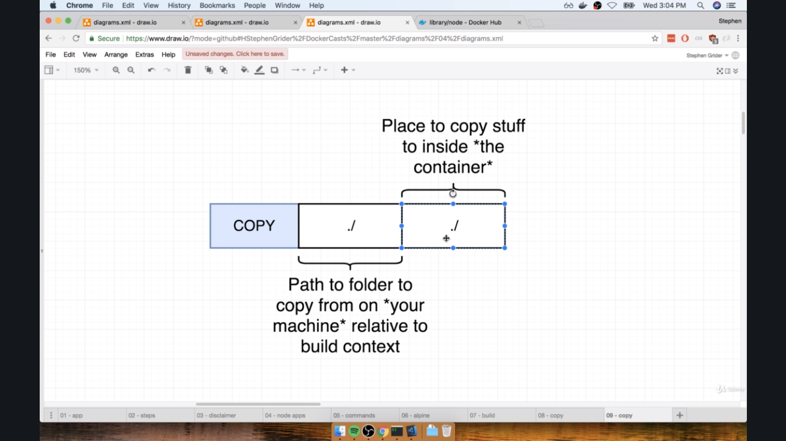

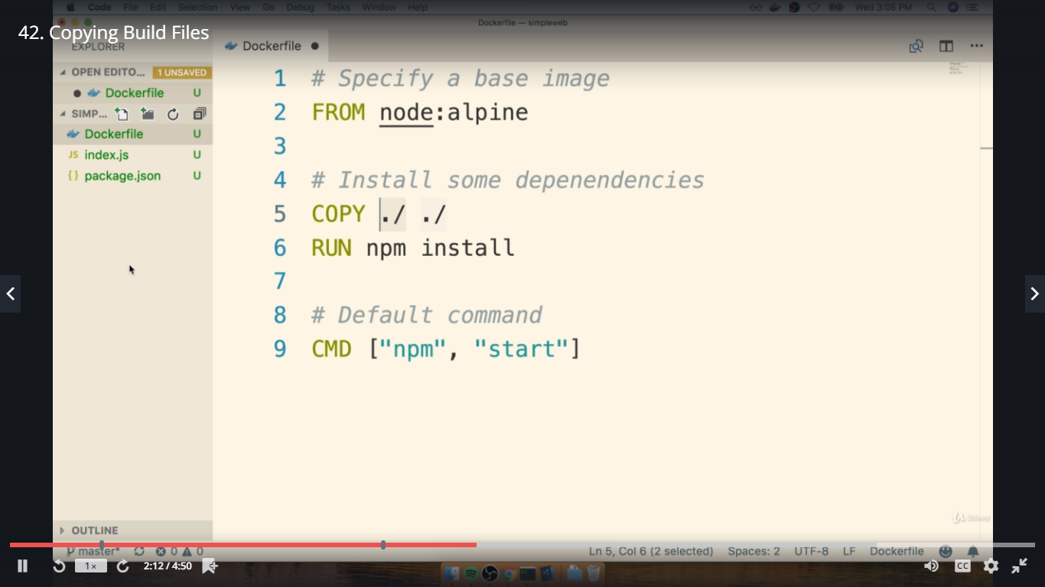

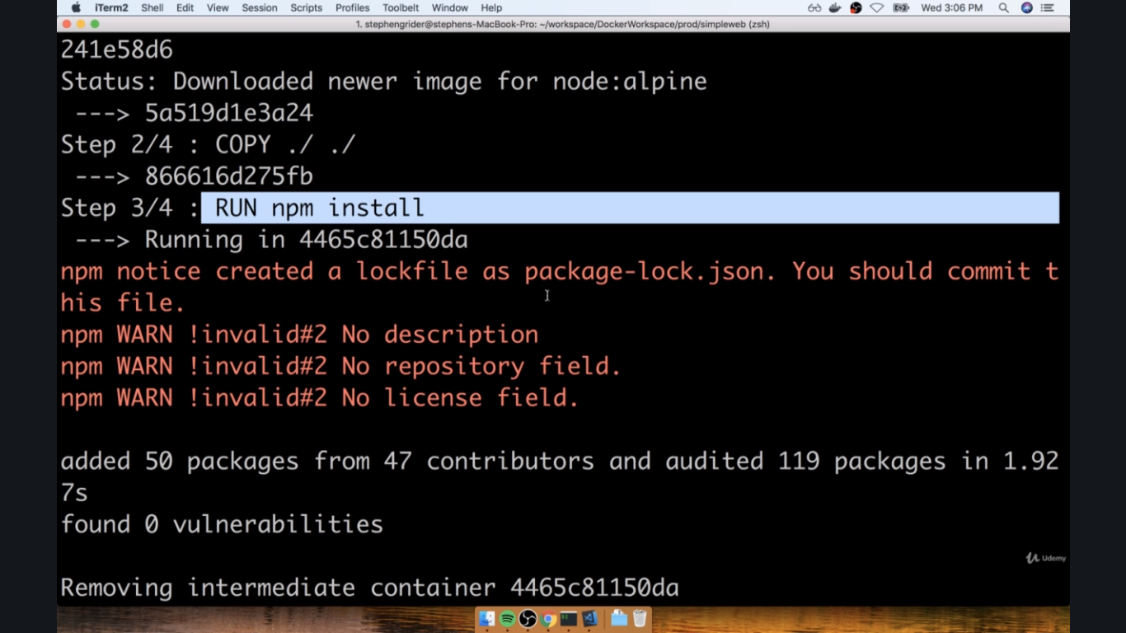

**So now successfully along with the filesx**

**Run using without id:**

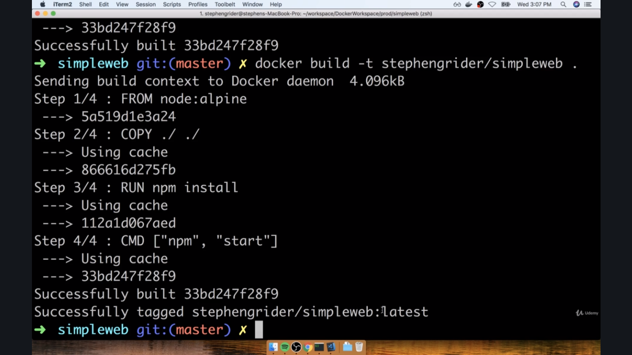

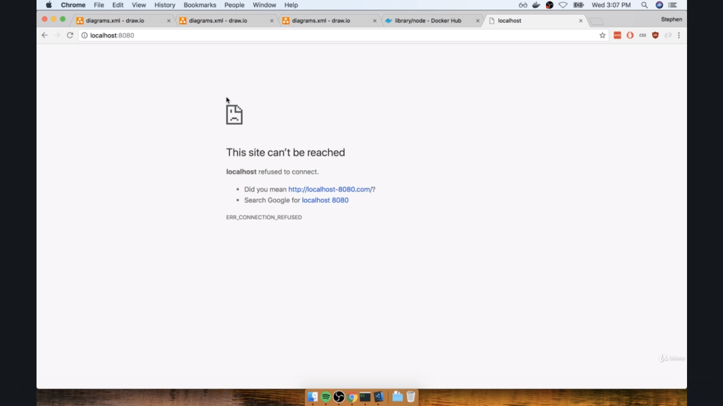

**Mapping to the port not done inside the port**

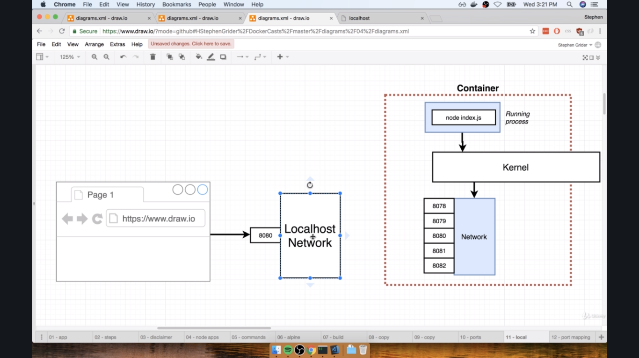

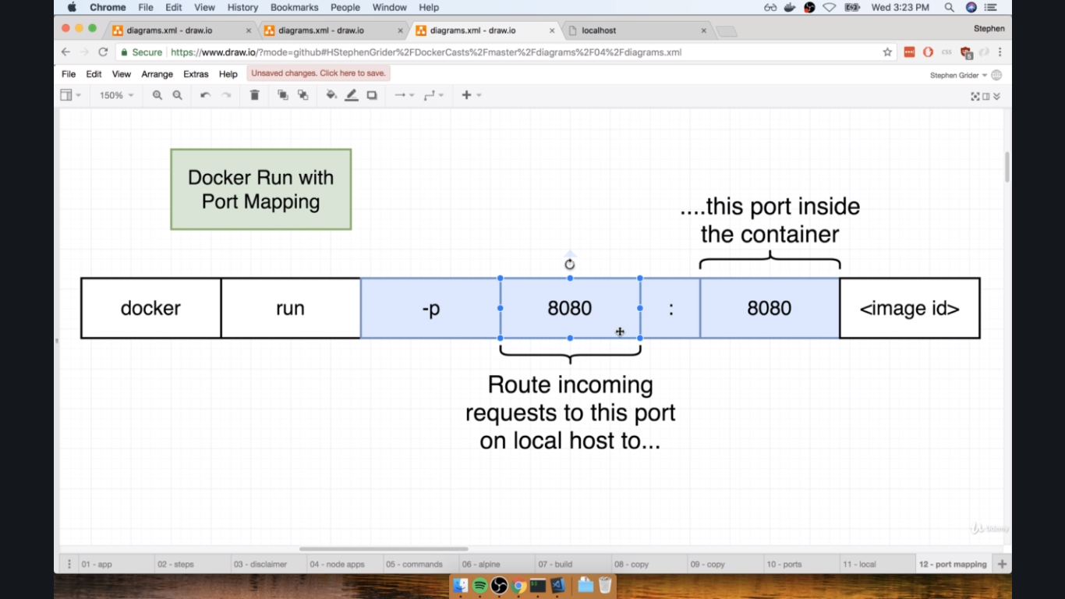

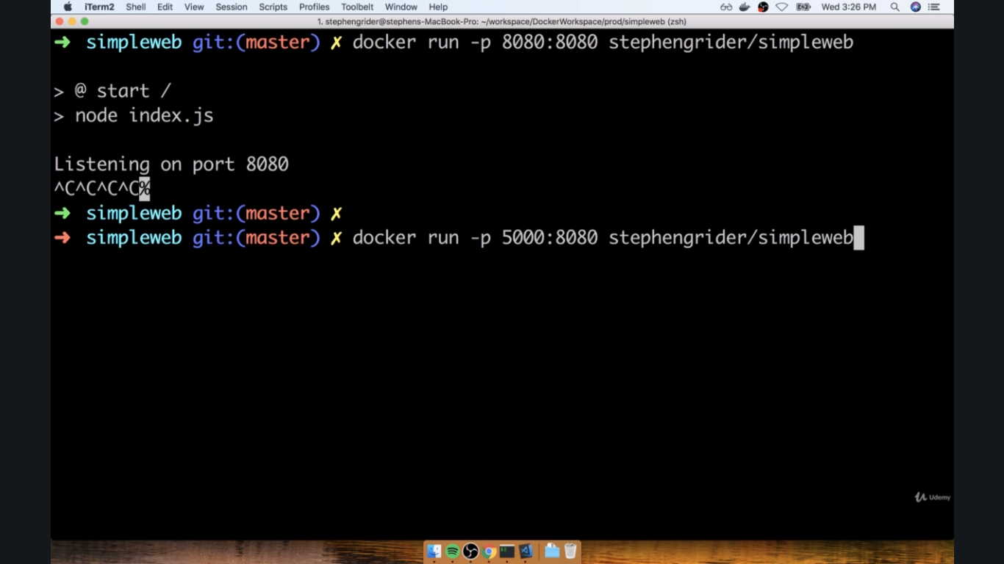

**Now run the web**

**Below we will use using sh**

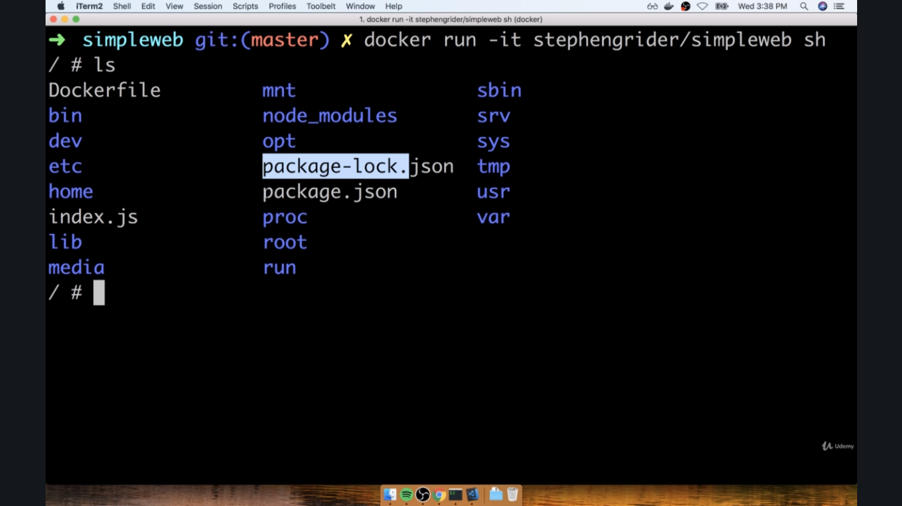

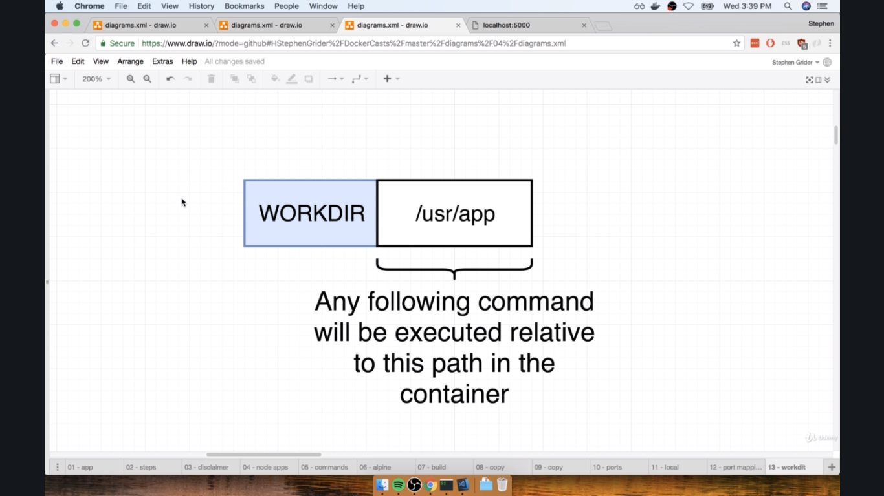

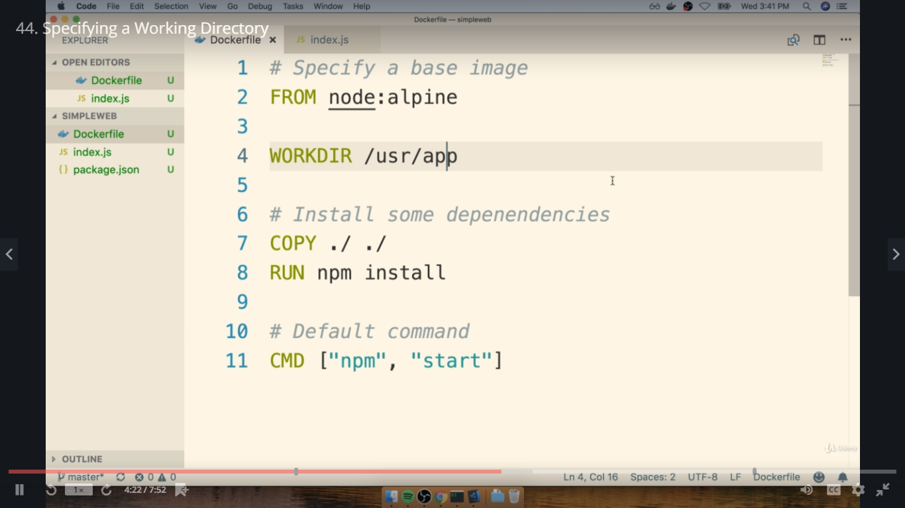

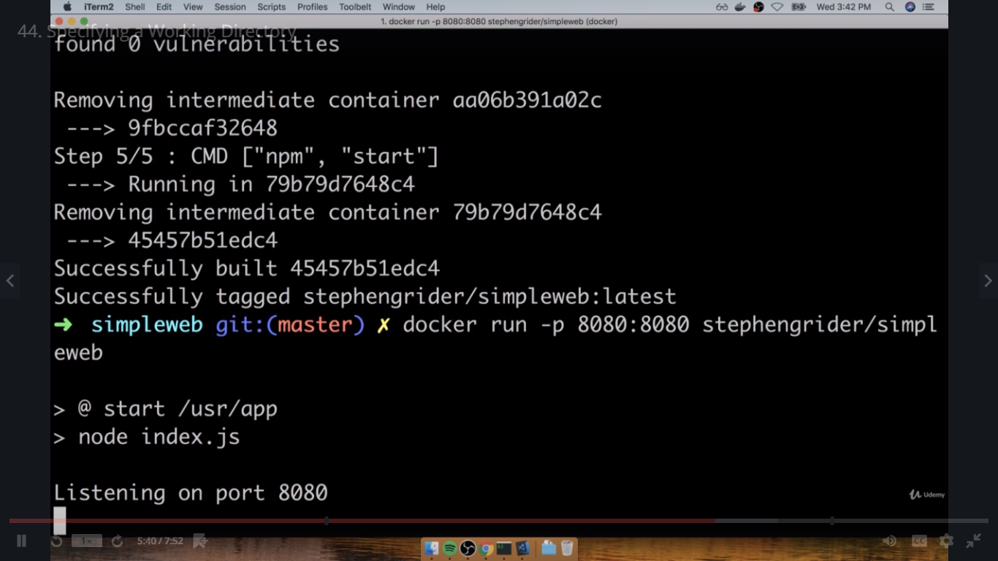

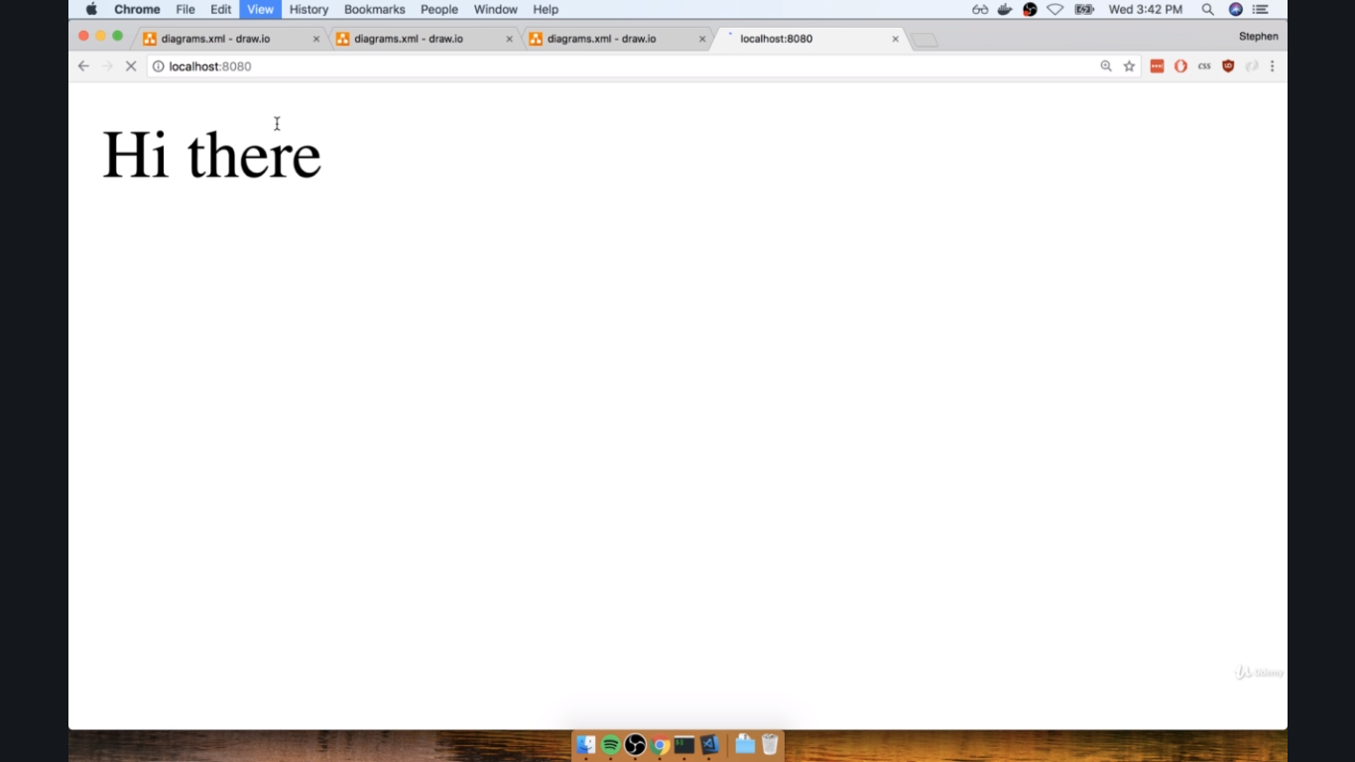

**Or use the following**

